Hands On 12: **Solution**

Implementing CI CD for .NET core Microservice on AWS

1. Consider the microservice which was created in the previous hands on and add one more HttpGet method which will return list of numbers

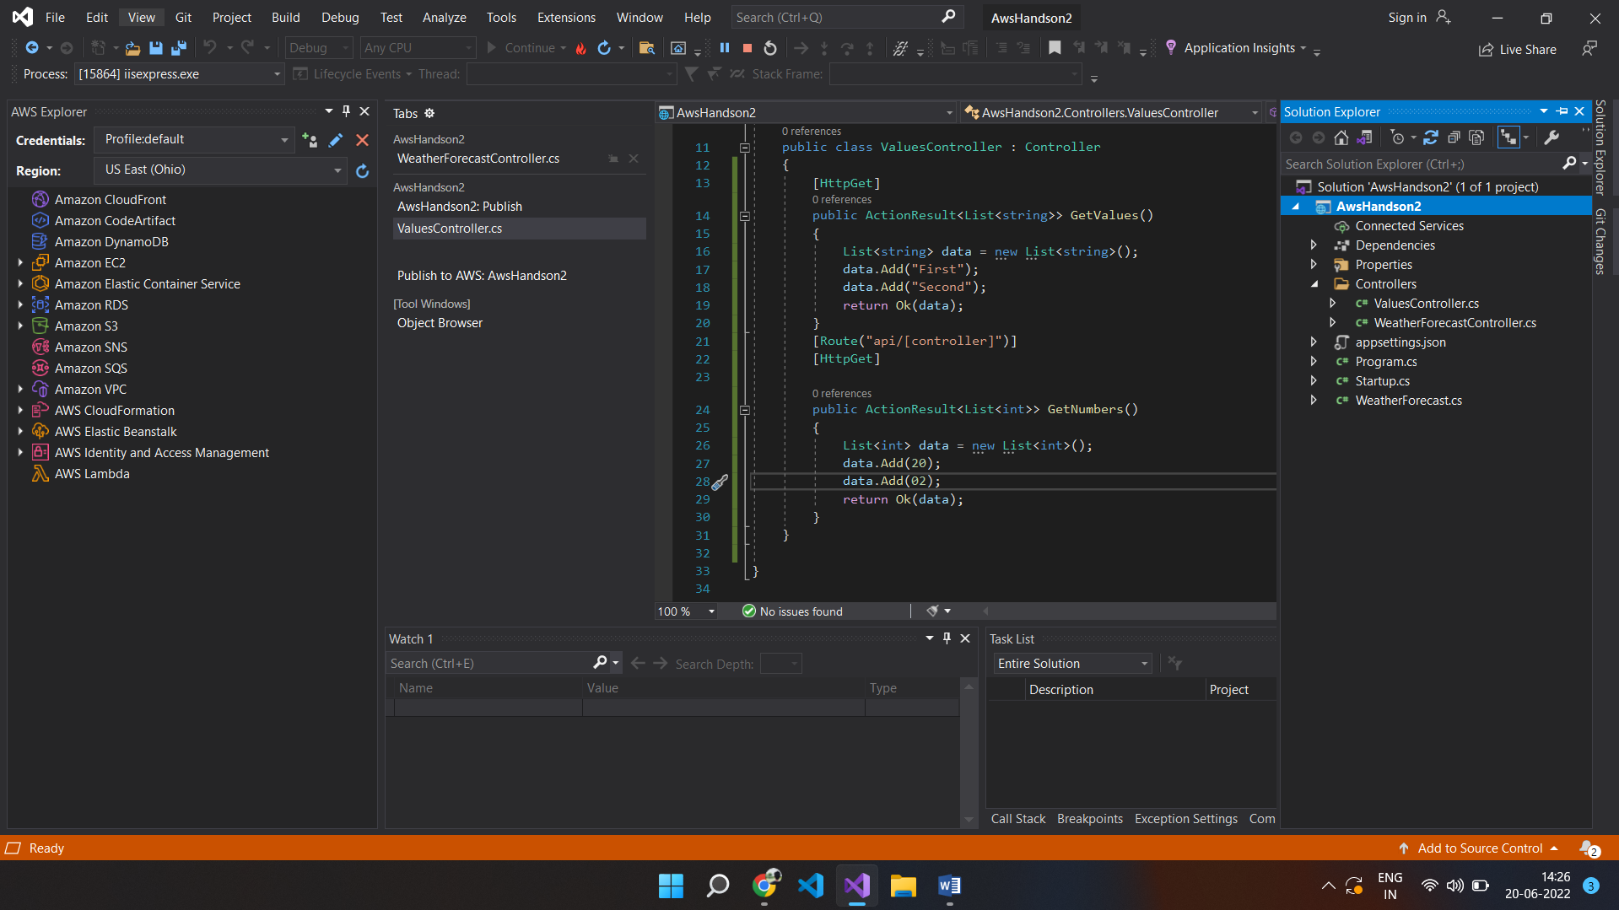

1. Execute the application in IIS in order to get the following output

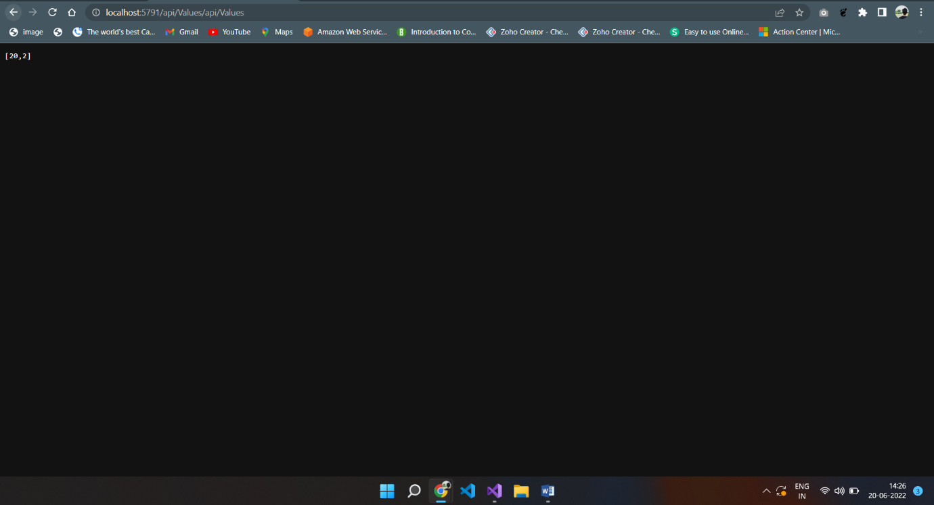

1. Make a note of the endpoint which returns the numbers.
2. Right click on the project and click on Publish to AWS and the following screen will appear.

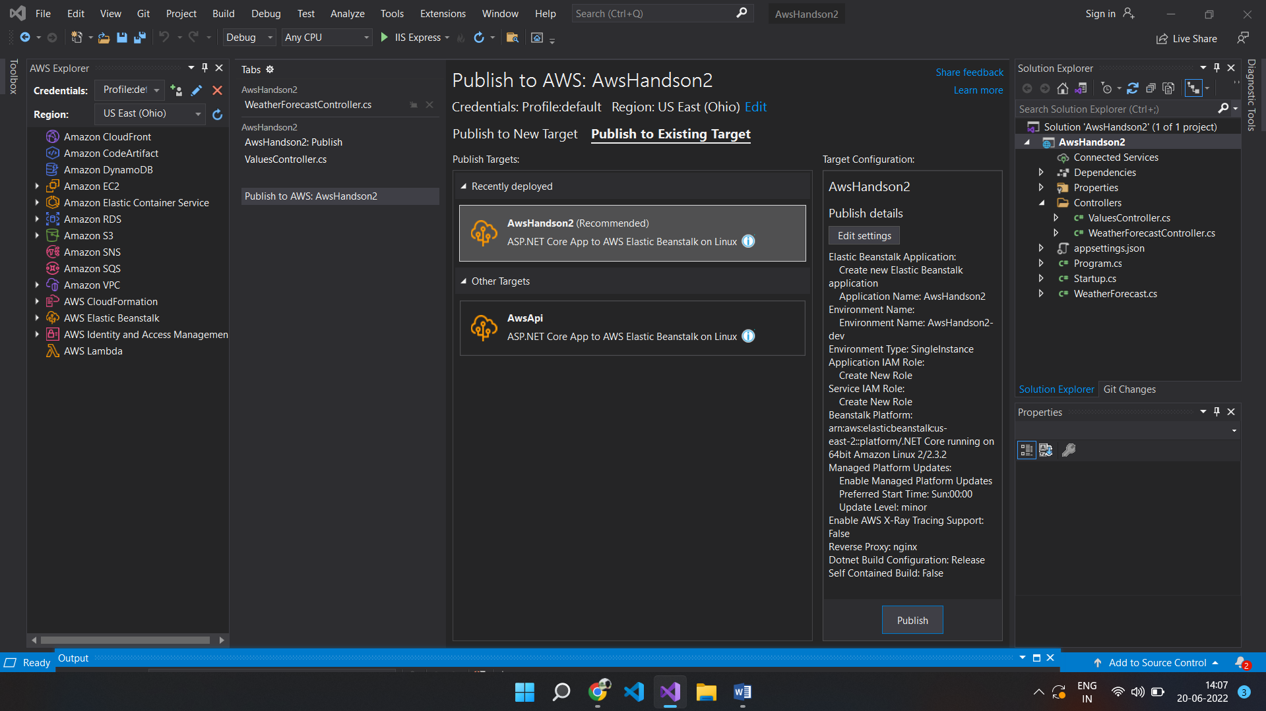

1. In AWS explorer, if you refresh Elastic BeanStalk, our “AwsHandon2” will appear. Now choose publish to “Existing Target” and click on Publish.
2. The following screen will appear.

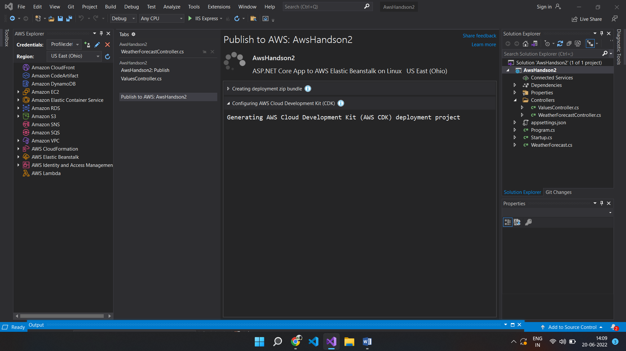

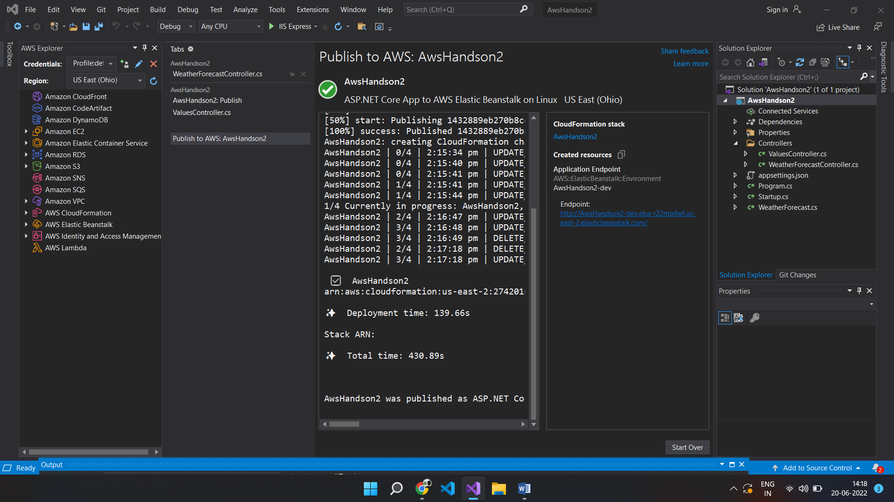

1. Now refresh the Url of the Elastic BeanStalk and try for the endpoint /api/Values/api/Values” and the following screen will appear.



1. As and when we make changes to our source code and publish, the same gets updated and deployed in AWS Beanstalk.

9. To Stop a EBS(Elastic BeanStalk) follow the steps below:

a. Choose configuration in the left side menu

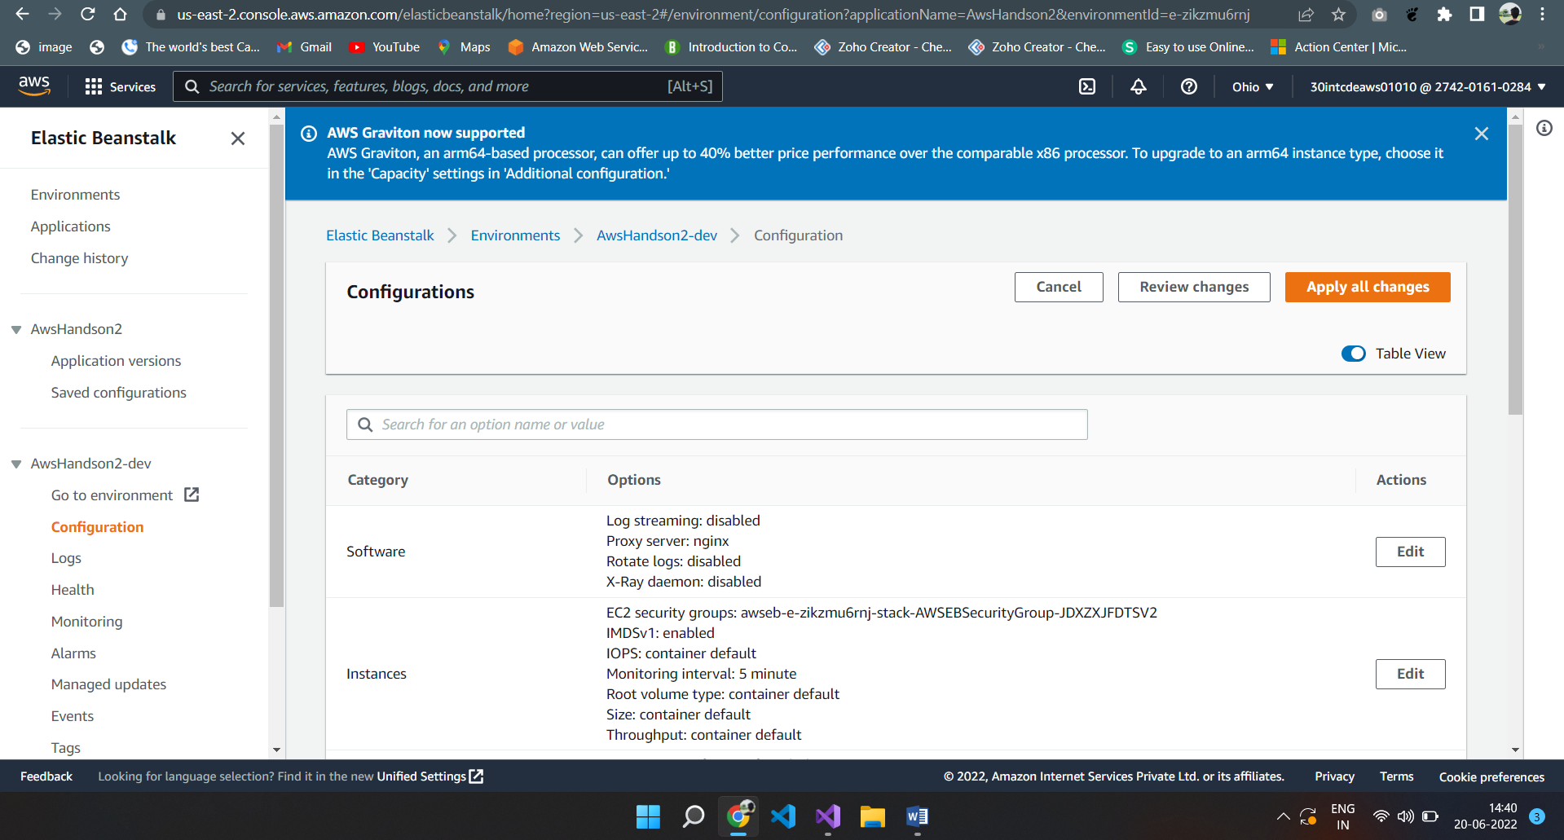

b. Click on Capacity à Edit à Scroll down to “Time based scaling” à Click on “Add Scheduled Action”

c. Fill the min and max instances to 0 as shown in the below screenshot

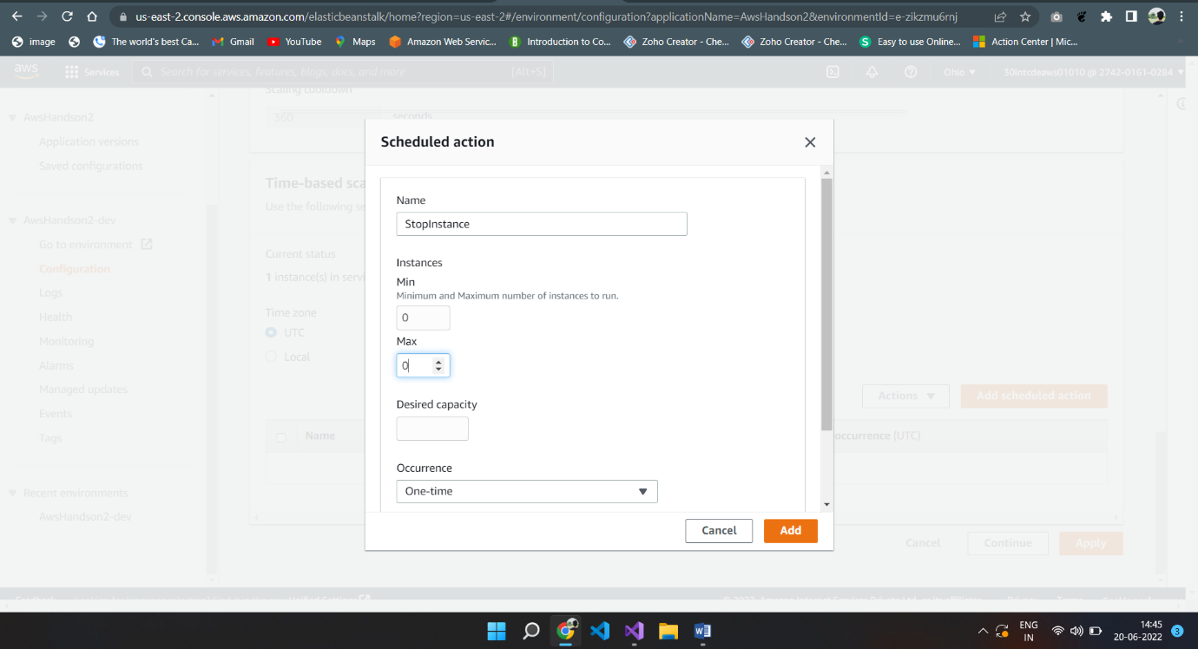

d. Click on Add and Apply and wait for 5 minutes and then try to access the end point. EBS would not have got stopped temporarily and we cannot access the end point.

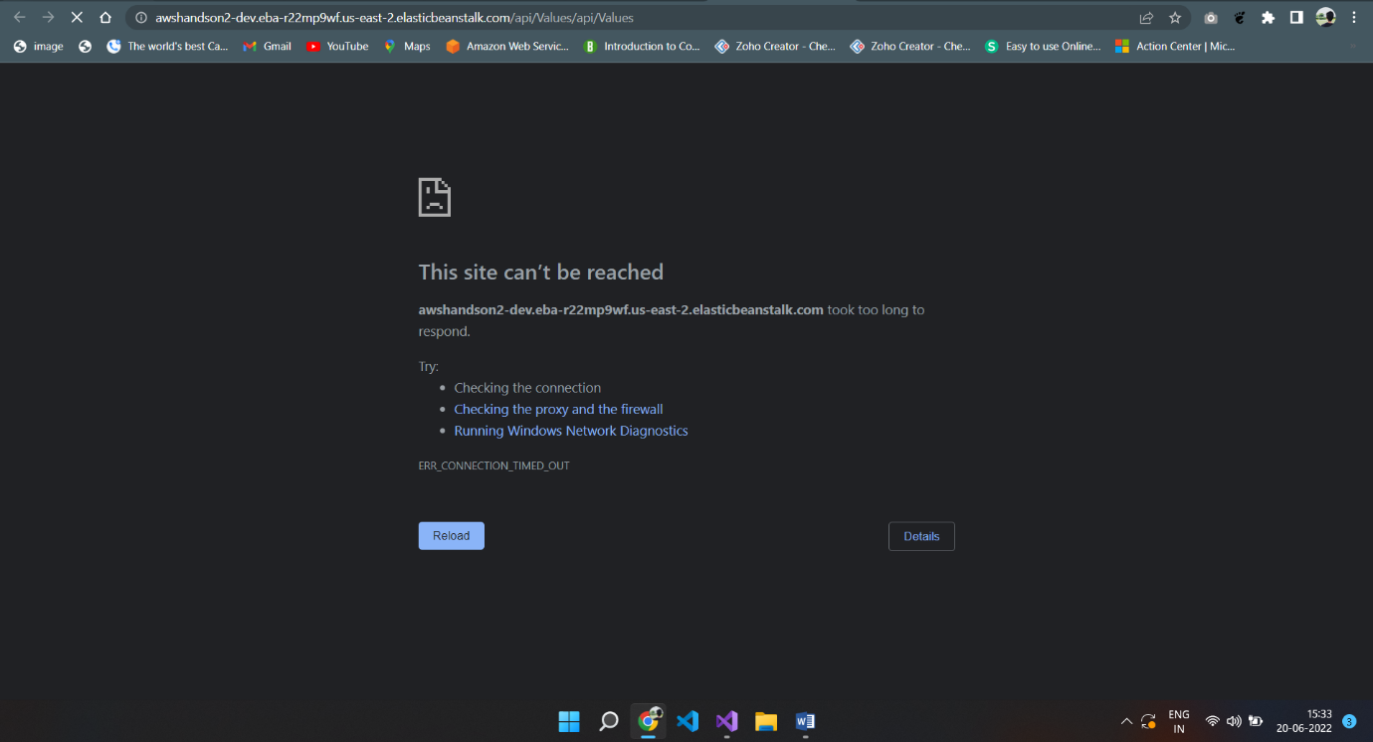

The instance is stopped.